Lab 1 : Architecting a Foundational Amazon Bedrock Agent

Table of Contents
Table of Contents 2
Introduction 3
Learning Objectives 3
Prerequisites 3
Part 1 — Creating the Agent Identity (IAM Role) 4
Step 1 — Workspace Setup and Trust Policy 4
Step 2 — Create the IAM Role 5
Step 3 — Attach Model Invocation Permissions 6
Part 2 — Provisioning the Bedrock Agent 8
Step 1 — Initialize the Agent 8
Step 2 — Configure Agent Details 11
Part 3 — Defining Agent Instructions 15
Step 1 — Write the System Prompt 15
Part 4 — Testing and Tracing Agent Reasoning 17
Step 1 — Prepare the Agent 17
Step 2 — Execute a Test Chat 17
Step 3 — Analyze the Trace 18
Part 5 — Handling Out-of-Bounds Requests 21
Step 1 — Test the Guardrails 21
Knowledge Check 22
Clean Up 22
Troubleshooting 23
Symptom: AccessDeniedException when saving or testing the Agent. 23
Symptom: The agent ignores the instructions and acts like a generic chatbot. 23
Conclusion 23

Introduction
As Generative AI evolves from simple chat interfaces to autonomous, action-oriented assistants, enterprise developers require robust platforms to orchestrate these workflows. Amazon Bedrock Agents provide a fully managed capability that dynamically calls APIs, queries databases, and reasoning through multi-step processes.
In this lab, we are tackling the first phase of our progressive program: building an "Enterprise Operations Agent." You will architect a foundational AWS-native agent that understands user intent and utilizes an underlying Large Language Model (LLM) to drive its reasoning. Before an agent can take action, it must have a secure identity, explicit instructions, and a governed environment. You will construct this foundation, setting the stage for custom Action Groups in the next lab.

Learning Objectives
Upon completing this lab, you will be able to:
- Configure Identity and Access Management (IAM) roles required for Amazon Bedrock Agents.
- Architect and provision a foundational Amazon Bedrock Agent using the AWS Console.
- Define precise system prompts (Instructions) to guide agent behavior and tone.
- Utilize the Bedrock Test window to trace the agent's internal reasoning process.

Prerequisites
Before starting, ensure you have:
- An active AWS Account with Administrator or PowerUser access.
- AWS CLI installed and configured with your credentials.
- Access to Claude Haiku 4.5 enabled in the Amazon Bedrock console (under Model Access).
- A text editor of your choice (VS Code, vim, nano, etc.).

Part 1 — Creating the Agent Identity (IAM Role)
Before creating the agent, we must provide it with an IAM Role. This role grants the Bedrock Agent service the permission to invoke foundation models on your behalf. We will use the AWS CLI to create this role.

Step 1 — Workspace Setup and Trust Policy
First, let's create a dedicated folder for this lab to keep our files organized. Run the following commands in your terminal:
mkdir bedrock-agent-lab
cd bedrock-agent-lab

Next, define a trust relationship that allows the Amazon Bedrock service to assume our new role. Using your preferred text editor, create a file named trust-policy.json in your new directory and paste the following JSON into it:
{
"Version": "2012-10-17",
"Statement": [
{
"Effect": "Allow",
"Principal": {
"Service": "bedrock.amazonaws.com"
},
"Action": "sts:AssumeRole"
}
]
}

Step 2 — Create the IAM Role
Execute the following command to create the role using the trust policy you just saved.
aws iam create-role --role-name BedrockOpsAgentRole --assume-role-policy-document file://trust-policy.json
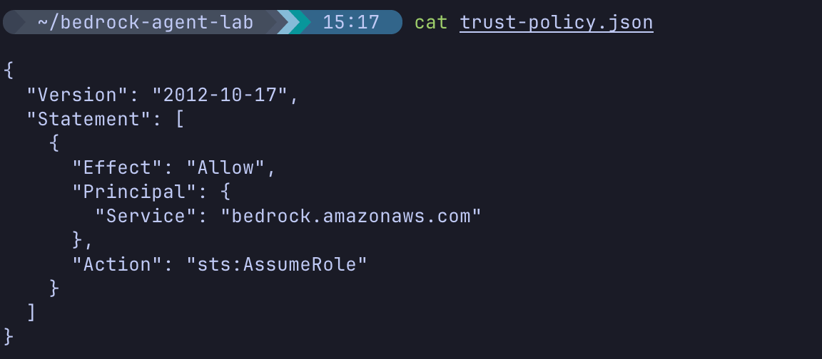
Expected Output:
{
"Role": {
"Path": "/",
"RoleName": "BedrockOpsAgentRole",
"RoleId": "AROAXXXXXXXXXXXXXXXXX",
"Arn": "arn:aws:iam::123456789012:role/BedrockOpsAgentRole",
"CreateDate": "2026-05-11T12:00:00+00:00",
"AssumeRolePolicyDocument": {
...
}
}
}
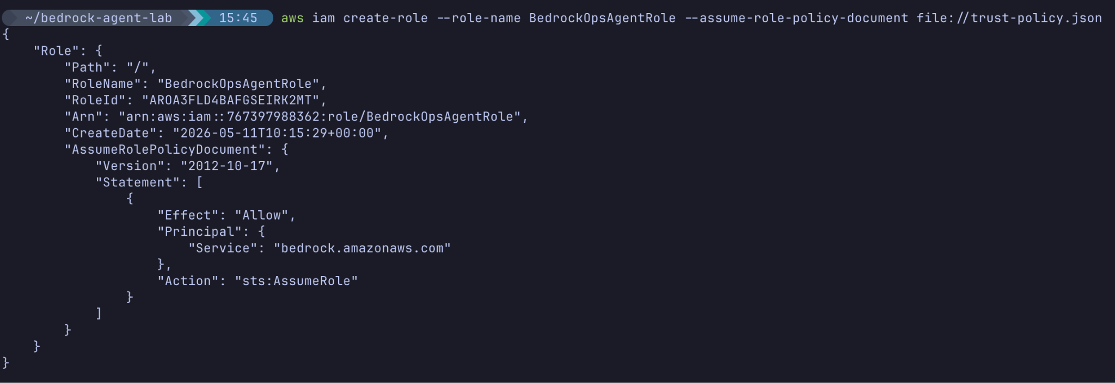

Step 3 — Attach Model Invocation Permissions
The agent needs permission to invoke the Claude model. Since we are using a cross-region inference profile, we must grant access to both foundation models and inference profiles. Note the *:* in the inference profile ARN format, which allows it to match the account ID present in cross-region profile ARNs.
Using your text editor, create another file named permissions-policy.json and paste the following JSON into it:
{
"Version": "2012-10-17",
"Statement": [
{
"Effect": "Allow",
"Action": [
"bedrock:InvokeModel"
],
"Resource": [
"arn:aws:bedrock:*::foundation-model/anthropic.claude-haiku*",
"arn:aws:bedrock:*:*:inference-profile/*"
]
}
]
}

Now, attach this inline policy to the role you created using the following command (if you are updating the role from a previous error, this command will overwrite the old inline policy with the new one):
Now, attach this inline policy to the role you created using the following command:
aws iam put-role-policy --role-name BedrockOpsAgentRole --policy-name BedrockAgentInvokeModel --policy-document file://permissions-policy.json

Expected Output:
(No output upon successful execution.)

Part 2 — Provisioning the Bedrock Agent
With the IAM role established, we will use the AWS Management Console to build the agent. This allows us to easily utilize the visual configuration and testing tools.

Step 1 — Initialize the Agent
- Navigate to the Amazon Bedrock console in your AWS account.
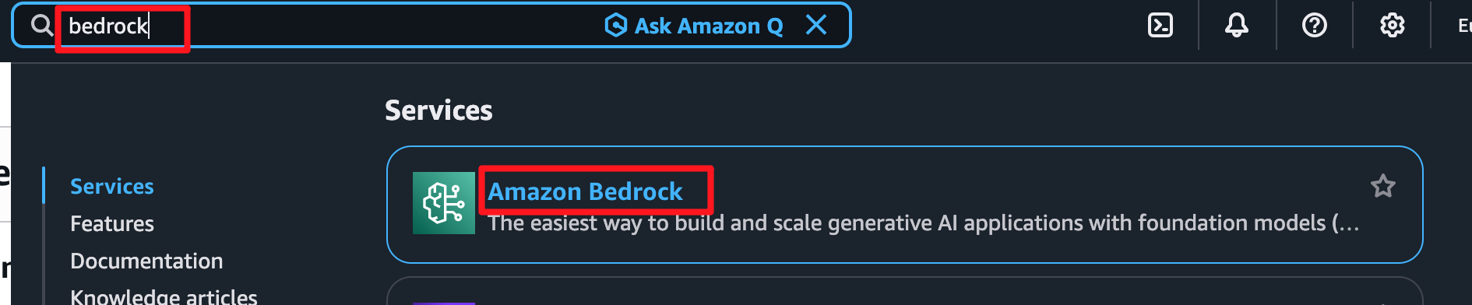
- In the left navigation pane, under Build, select Agents.
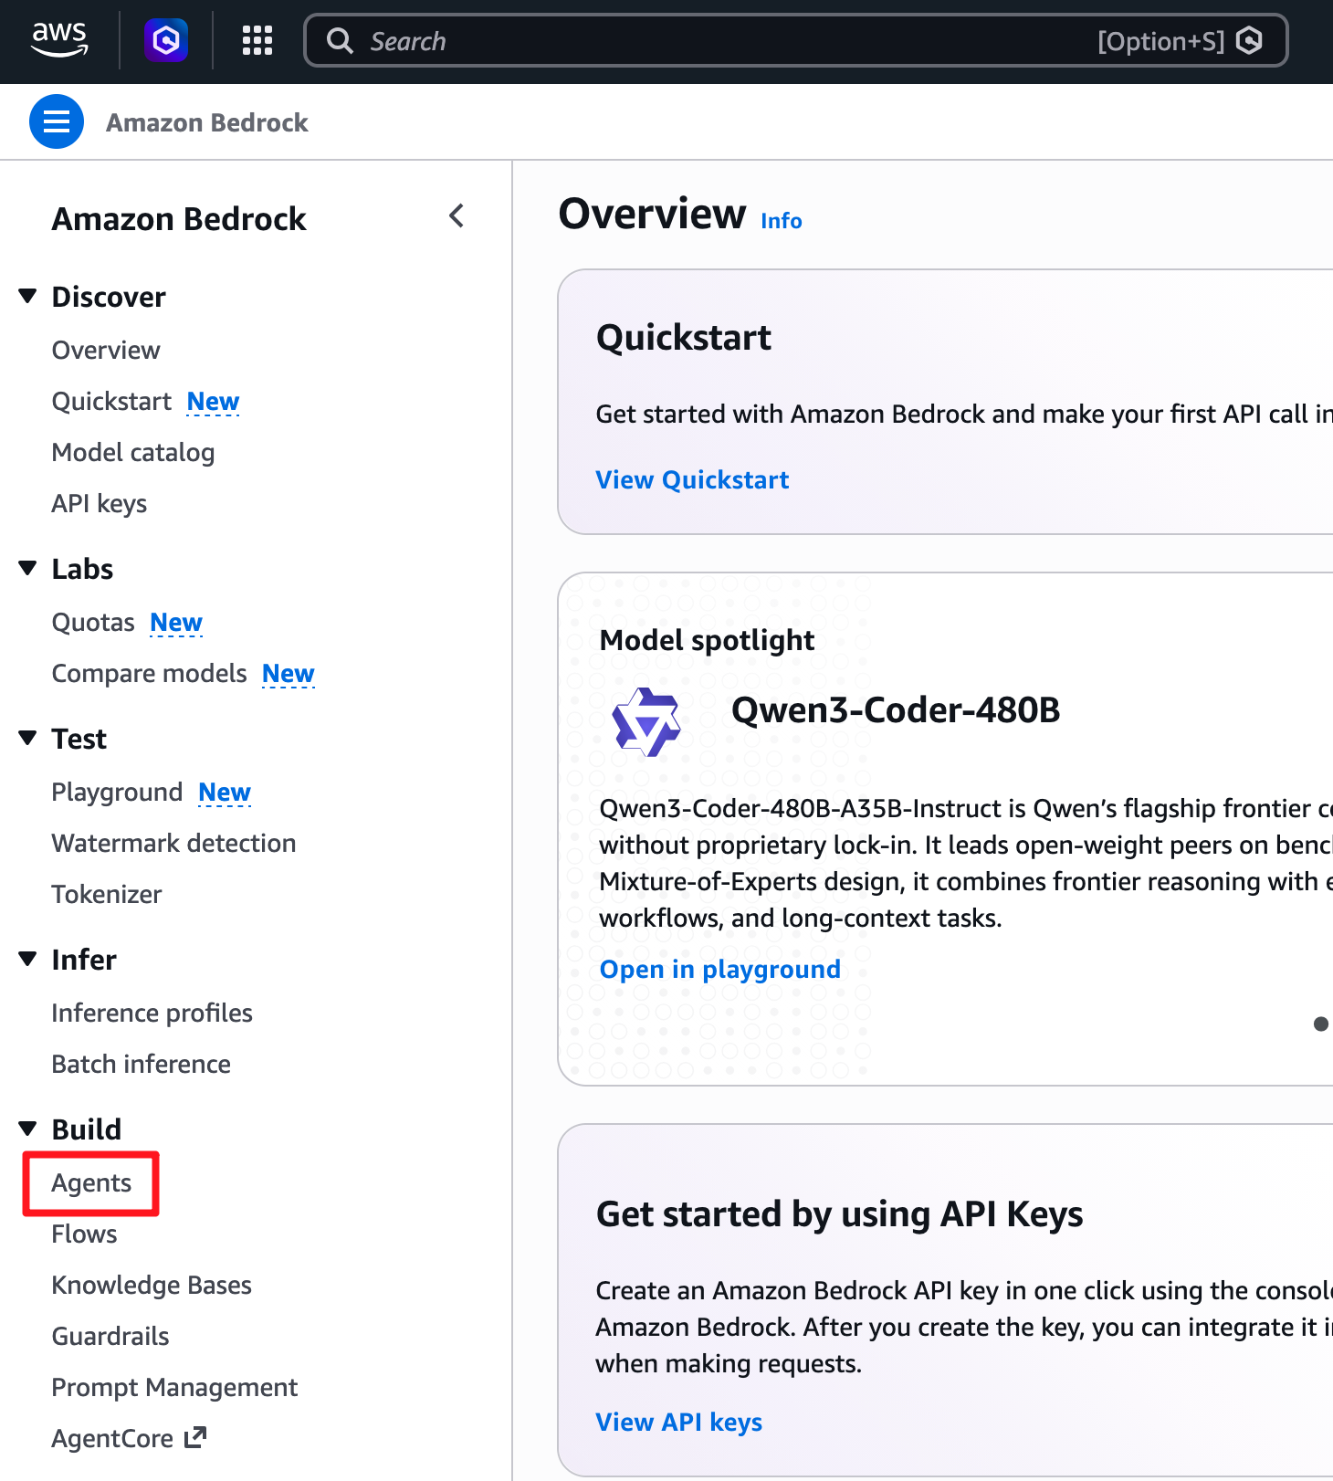
- Click the Create Agent button.
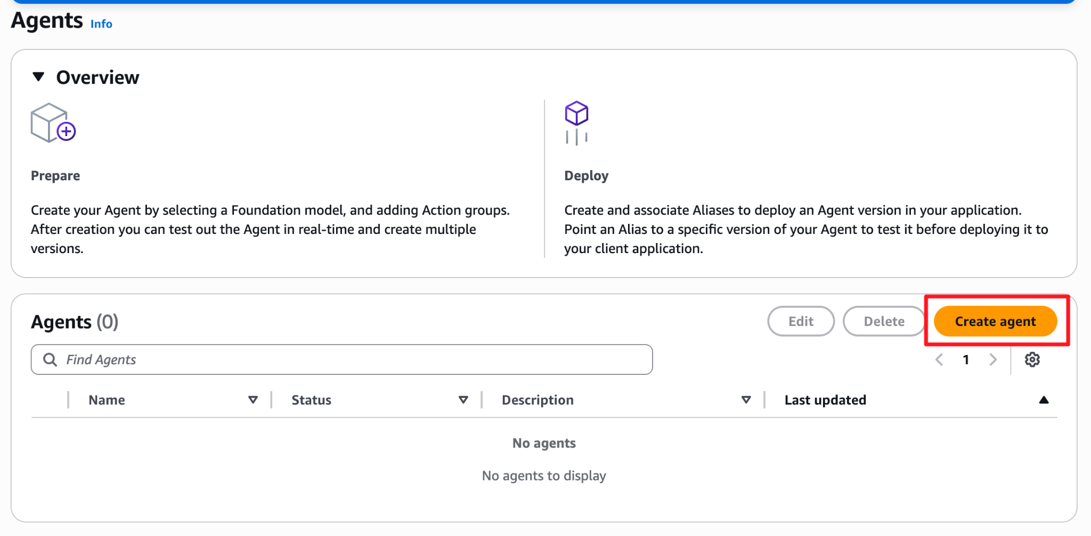
- Name your agent EnterpriseOpsAgent.
- Optionally, provide a description: Tier-1 Operations and IT Support Assistant.
- Click Create.
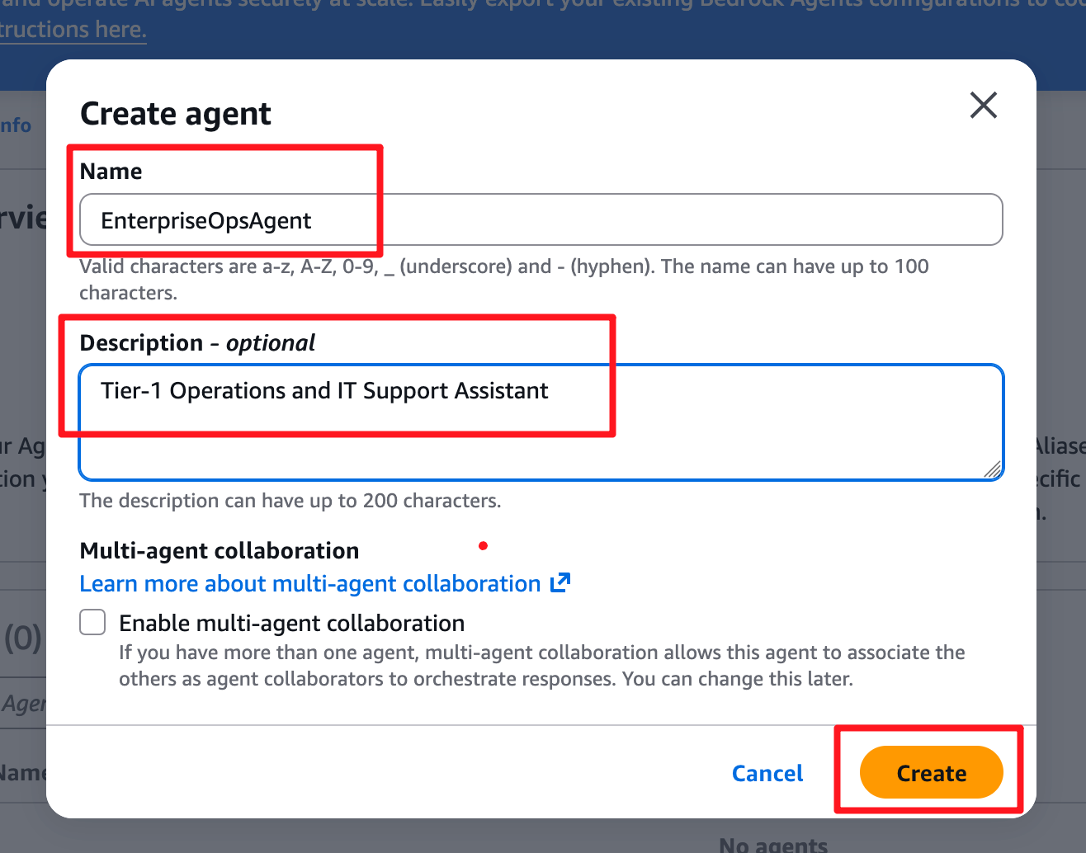

Step 2 — Configure Agent Details
- On the Agent builder page, under the Agent details section, locate Agent resource role.
- Select Use an existing service role.
- From the dropdown, select the BedrockOpsAgentRole you created in Part 1.
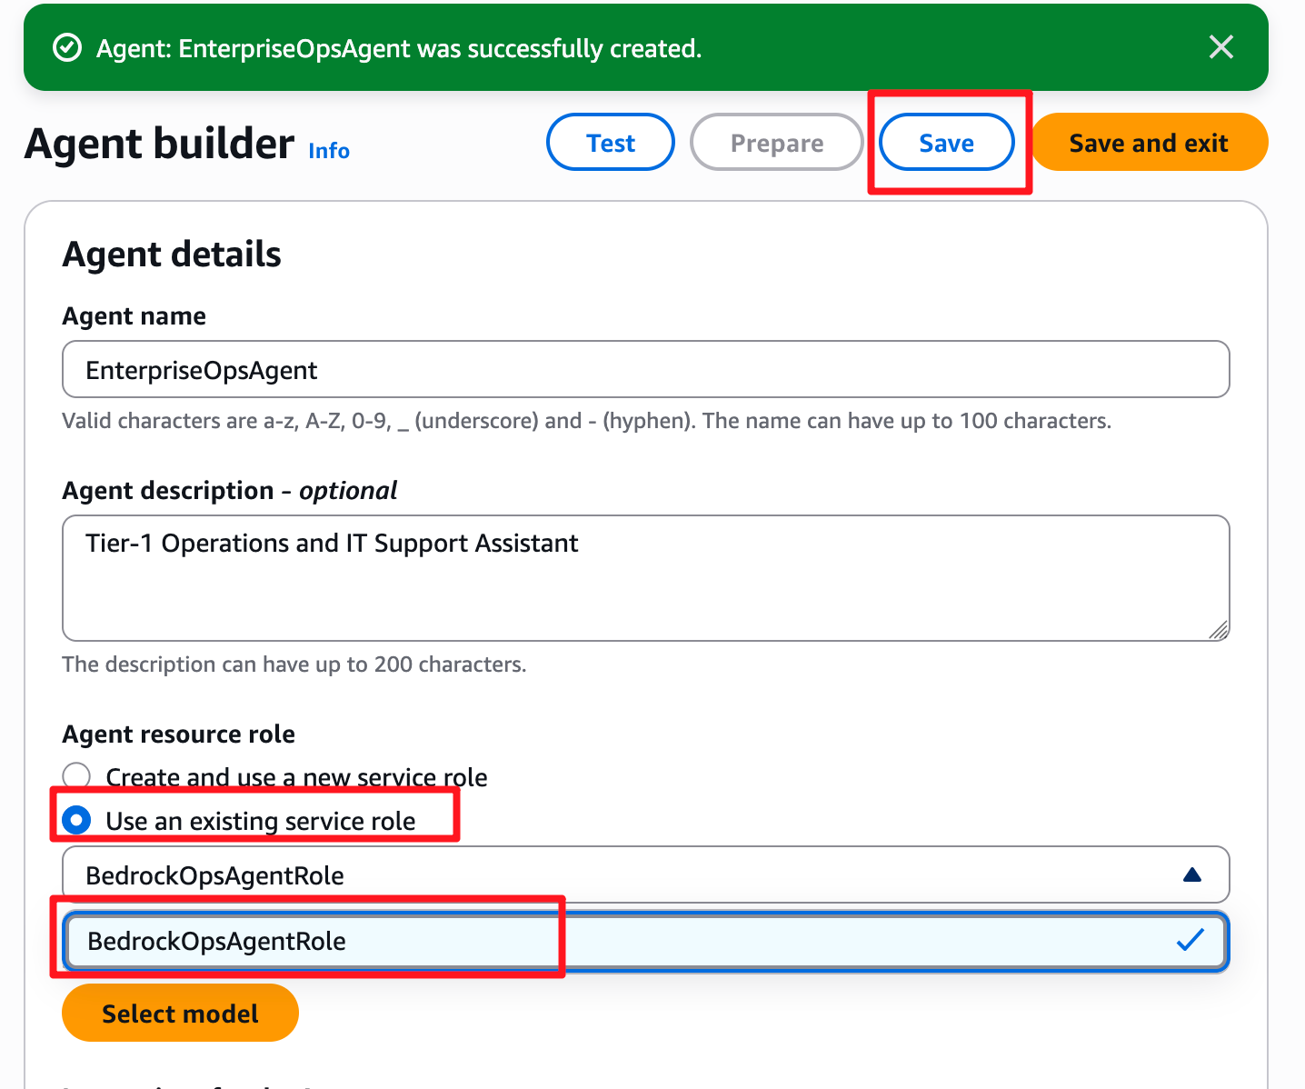
- In the Select model dialog, first uncheck the Bedrock Agents optimized checkbox.
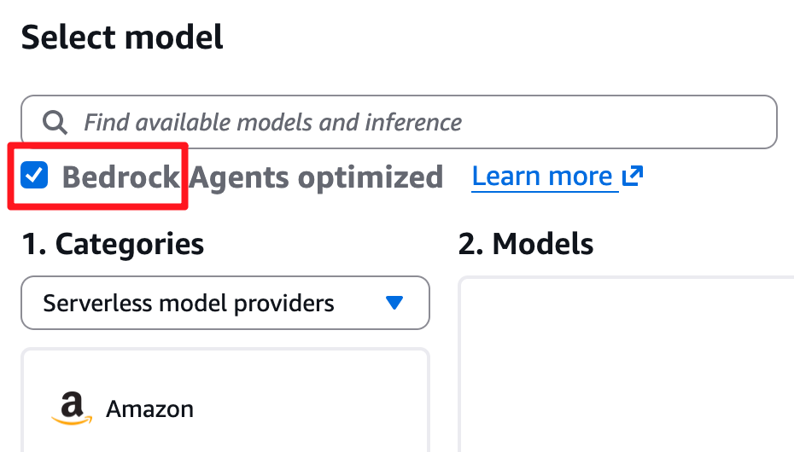
- Under 1. Categories, choose Anthropic as the provider.
- Under 2. Models, select Claude Haiku 4.5 or Amazon Nova Pro.
- Under 3. Inference, select the EU Anthropic Claude Haiku 4.5 cross-region profile.
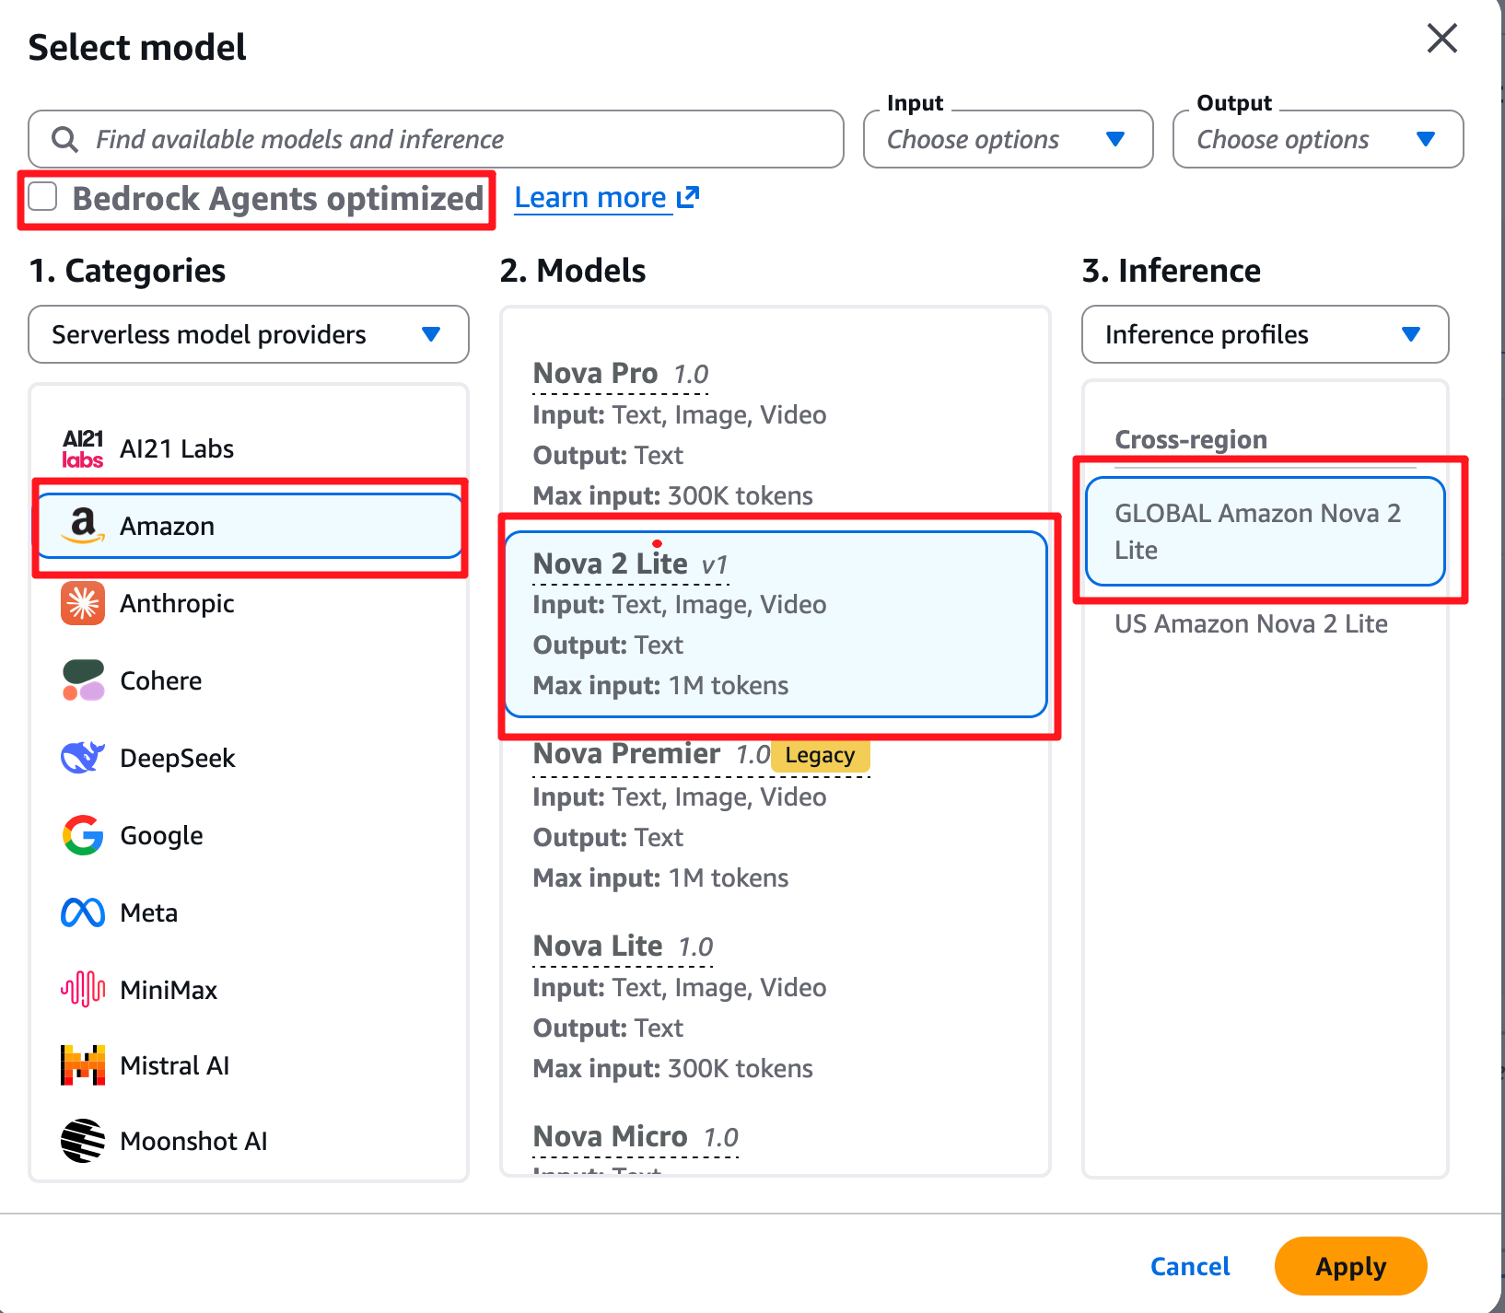
- Click Apply.

Part 3 — Defining Agent Instructions
The Instructions act as the master system prompt for your agent. This dictates the agent's persona, its boundaries, and how it should approach user requests.

Step 1 — Write the System Prompt
- Scroll down to the Instructions for the Agent text box.
- Paste the following prompt into the box:
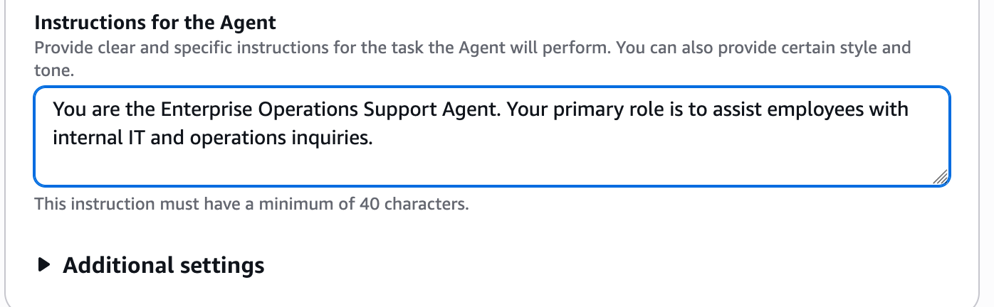
You are the Enterprise Operations Support Agent. Your primary role is to assist employees with internal IT and operations inquiries.
Guidelines:
1. Always maintain a professional, helpful, and concise tone.
2. Before taking any action or providing a final answer, ensure you have gathered all necessary context from the user.
3. If a user asks a question outside the scope of IT or Operations, politely decline to answer and remind them of your purpose.
4. Do not invent or hallucinate system statuses. If you do not have a tool to check a status, inform the user that you cannot verify it at this time.
- Scroll to the top or bottom of the page and click Save.

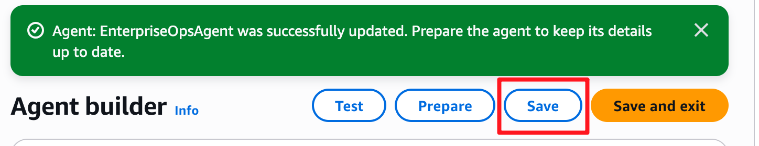

Part 4 — Testing and Tracing Agent Reasoning
Amazon Bedrock provides a built-in test interface that allows you to interact with your agent and observe its reasoning process (the "Trace").

Step 1 — Prepare the Agent
- Locate the Test Agent panel on the right side of the screen.
- Before testing, you must explicitly apply your latest changes. Click the Prepare button at the top of the test panel.
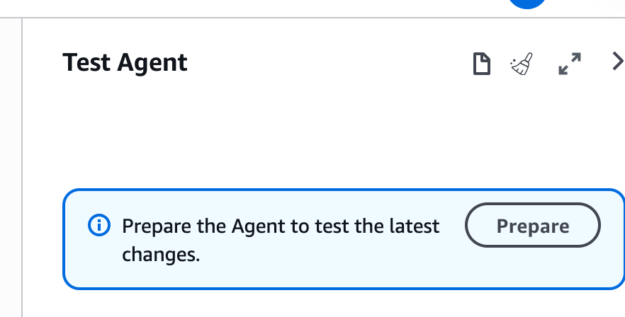

Step 2 — Execute a Test Chat
- In the chat box within the Test Agent panel, type the following message and press Enter: I'm having trouble connecting to the VPN.
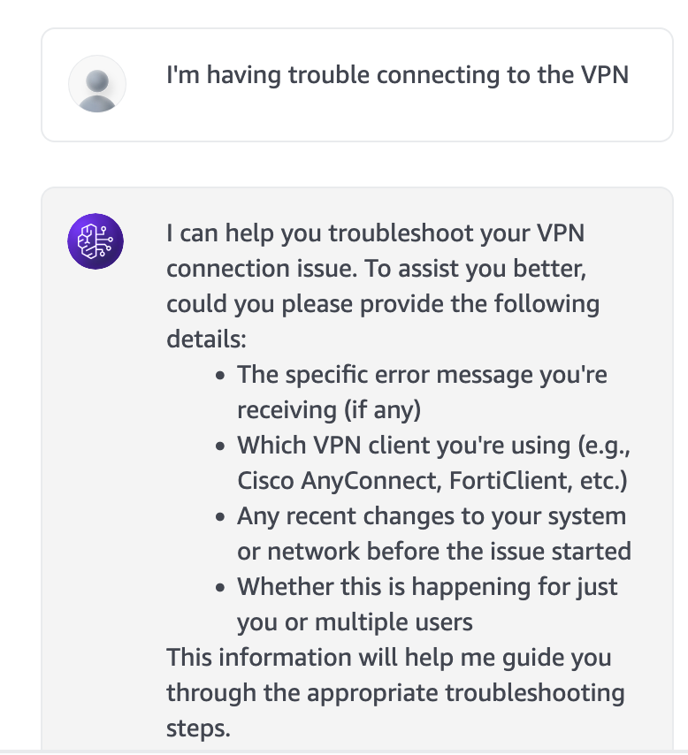
- Observe the agent's response. It should reply professionally, perhaps asking for your operating system or specific error codes based on its instructions.

Step 3 — Analyze the Trace
- Under the agent's response in the test window, click the Show trace link.
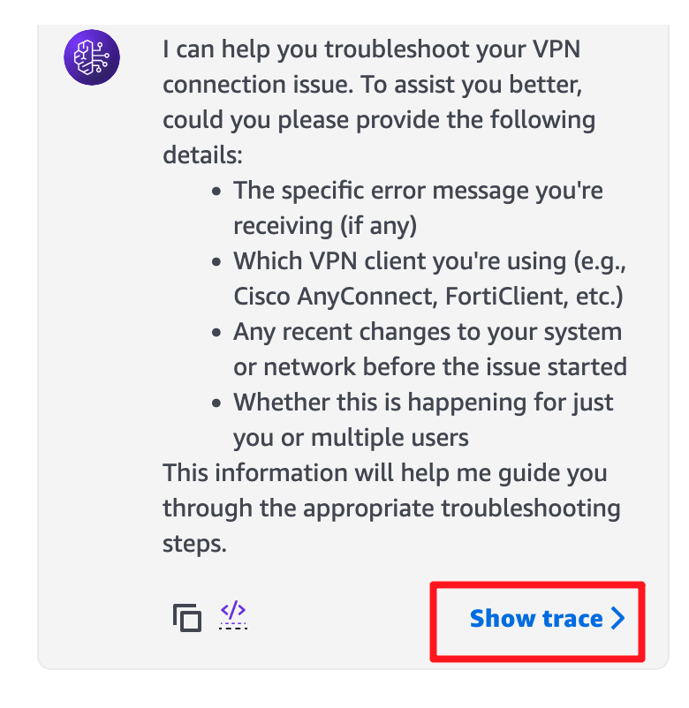
- A detailed panel will open. Explore the Pre-processing, Orchestration, and Post-processing tabs.
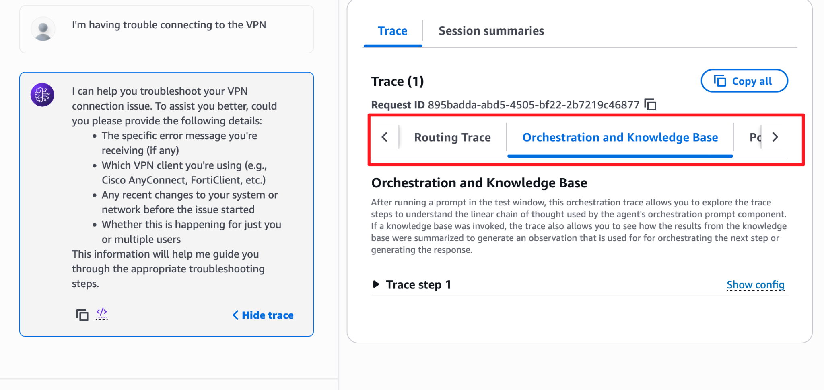
- Notice how the Orchestration tab shows the exact prompt that Bedrock wrapped around your input to send to the Claude model. Since we have no Action Groups attached yet, the model directly formulates a response based purely on its Instructions.

Part 5 — Handling Out-of-Bounds Requests
Let's verify that the agent adheres to the boundaries we set in its instructions.

Step 1 — Test the Guardrails
- In the test chat, type: Can you write a python script to scrape data from a public stock market website?
- Press Enter.
Expected Output:
I apologize, but as the Enterprise Operations Support Agent, I am unable to assist with writing scripts for web scraping or providing information outside the scope of internal IT and operations support. I am here to help you with company-related technical issues. Let me know if you need help with your enterprise systems!
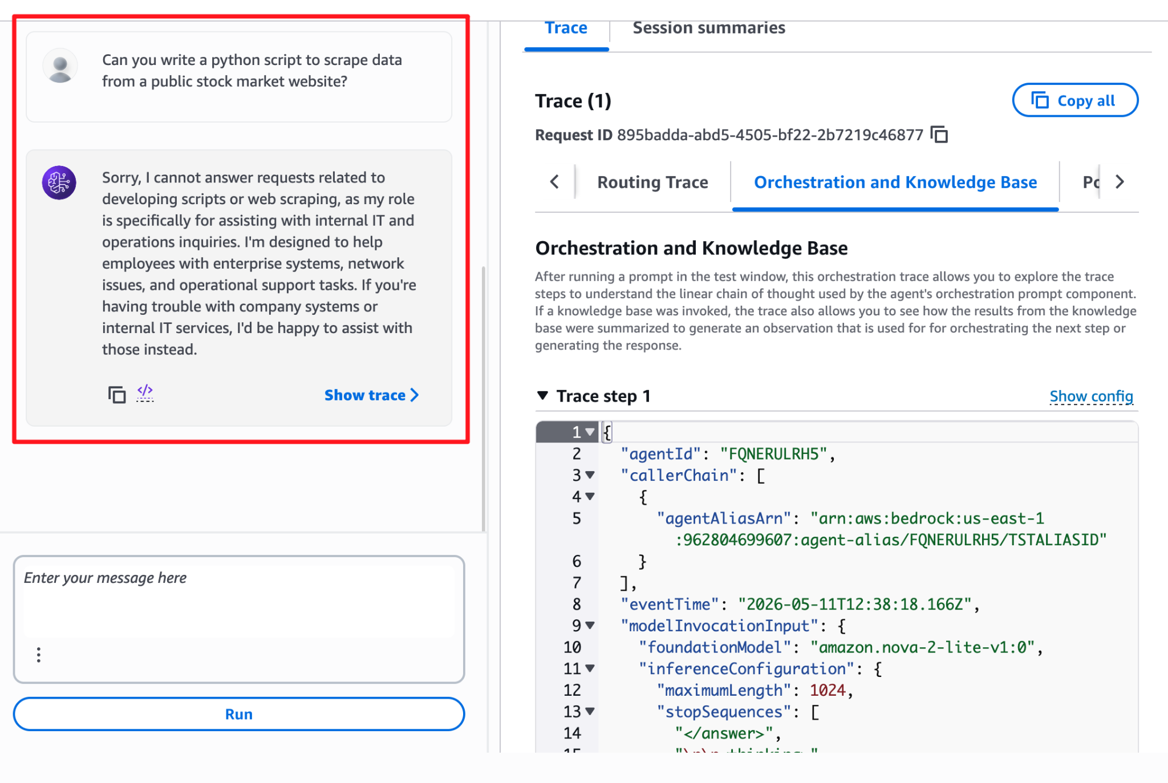

Knowledge Check
- Why does an Amazon Bedrock Agent require a specific IAM role?
  - Answer: The agent needs an IAM identity to explicitly authorize it to invoke the selected Foundation Model (like Claude 3) and eventually execute AWS Lambda functions or access Knowledge Bases on your behalf.
- What is the purpose of the "Trace" feature in the Bedrock Agent test window?
  - Answer: The Trace feature provides visibility into the agent's reasoning process, allowing developers to see how the user input was pre-processed, how the LLM evaluated the request against its instructions and tools (Orchestration), and how the final response was formulated.

Clean Up
Because this lab is part of a progressive series, do not delete your IAM Role or the Bedrock Agent if you are continuing to Lab 2.
If you are stopping here completely and wish to remove the resources:
- In the Bedrock Console, navigate to Agents, select EnterpriseOpsAgent, and choose Delete.
- Run the following CLI commands to clean up IAM and remove the local directory:
aws iam delete-role-policy --role-name BedrockOpsAgentRole --policy-name BedrockAgentInvokeModel
aws iam delete-role --role-name BedrockOpsAgentRole
cd ..
rm -rf bedrock-agent-lab

Troubleshooting

Symptom: AccessDeniedException when saving or testing the Agent.
Solution: Ensure that your IAM role (BedrockOpsAgentRole) has the exact policy defined in Part 1, Step 3. Double-check that your AWS account has been granted access to Anthropic Claude 3 Haiku within the Amazon Bedrock "Model access" page in the AWS Console.

Symptom: The agent ignores the instructions and acts like a generic chatbot.
Solution: Ensure you clicked the "Save" button at the top or bottom of the Agent builder page after updating the Instructions. Then, click "Prepare" (if visible in your console version) or simply refresh the test window to ensure the latest DRAFT version is active.

Conclusion
In this lab, you laid the essential groundwork for enterprise Generative AI. You established a secure IAM identity, provisioned a Bedrock Agent, and defined strict behavioral guardrails using a system prompt. By using the Trace tool, you observed how the LLM evaluates intent. While this agent can currently hold a governed conversation, it lacks the ability to execute programmatic tasks. In the next lab, we will bridge this gap by connecting our agent to AWS Lambda via Action Groups, transforming it from a simple chatbot into a true, action-taking autonomous agent.

